Accounting Alert
Financial Reporting Standards

December 14, 2016

Topics covered:
- Annual Improvements to IFRS 2014-2016 Cycle
- Transfers of Investment Property
- IFRIC 22, Foreign Currency Transactions and Advance Consideration

Annual Improvements to IFRS 2014-2016 Cycle

The International Accounting Standards Board (IASB) has published ‘Annual Improvements to International Financial Reporting Standards (IFRS) 2014-2016 Cycle’ which addresses non-urgent (but necessary) minor amendments to three standards, as described below.

This publication is a collection of amendments to IFRS resulting from issues that were discussed by the IASB during the project cycle for making annual improvements that began in 2014 and which were included in an Exposure Draft published in November 2015. The IASB uses the Annual Improvements process to make necessary, but non-urgent, amendments to IFRS that will not be included as part of any other project. By presenting the amendments in a single document rather than as a series of piecemeal changes, the IASB aims to ease the burden of change for all concerned. A summary of the issues addressed is set out below.

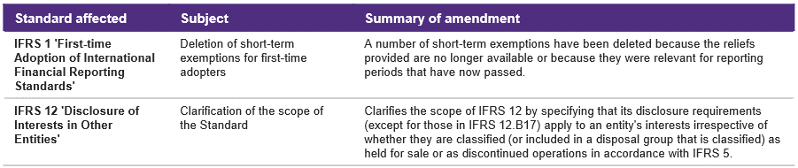

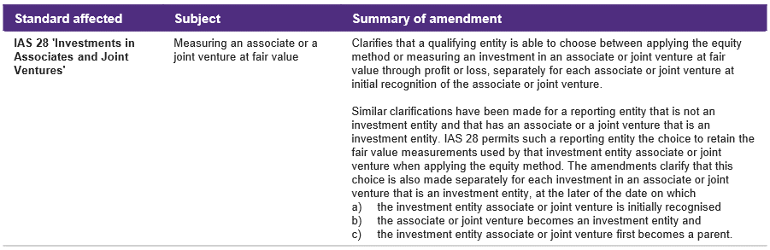

Effective dates
The amendments are effective as follows:
- IFRS 1, First-time Adoption of IFRS – for annual periods beginning on or after January 1, 2018
- IFRS 12, Disclosures of Other Entities – retrospectively in accordance with IAS 8, Accounting Policies, Changes in Accounting Estimates and Errors, for annual periods beginning on or after January 1, 2017
- IAS 28, Investments in Associates and Joint Ventures – retrospectively in accordance with IAS 8 for annual periods beginning on or after January 1, 2018; however, early application is permitted

Transfers of Investment Property

Introduction
The IASB has published ‘Transfers of Investment Property (Amendments to IAS 40)’ which clarifies that transfers to, or from, investment property are required when, and only when, there is a change in use of property supported by evidence.
The amendments
In addition to clarifying the above-noted principle, the amendments also re-characterize the list of circumstances appearing in paragraph 57(a)-(d) as a non-exhaustive list of examples of evidence that a change in use has occurred. The IASB has also clarified that a change in management’s intent, by itself, does not provide sufficient evidence that a change in use has occurred. Evidence of a change in use must be observable.

Effective date and transition
The amendments are effective for accounting periods on or after January 1, 2018; however, early application is permitted. The amendments contain transitional provisions, the default being prospective application; however, retrospective application is permitted, provided that it is possible without the use of hindsight.

IFRIC 22, Foreign Currency Transactions and Advance Consideration

Executive summary
The IFRS Interpretation Committee (IFRIC) has issued ‘IFRIC 22, Foreign Currency Transactions and Advance Consideration.’ It looks at what exchange rate to use for translation when payments are made or received in advance of the related asset, expense or income.
Background
Although IAS 21, The Effects of Changes in Foreign Exchange Rates, sets out requirements about which exchange rate to use when recording a foreign currency transaction on initial recognition in an entity’s functional currency, IFRIC had observed diversity in practice in circumstances in which an entity recognizes a non-monetary liability arising from advance consideration. The diversity resulted from the fact that some entities were recognizing revenue using the spot exchange rate at the date of the receipt of the advance consideration while others were using the spot exchange rate at the date that revenue is recognized.
In carrying out their analysis of the issue, IFRIC noted that the issue was not restricted to just revenue transactions. For example, the same issue arises for transactions such as a sale of property, plant and equipment or the purchase of services when consideration is denominated in a foreign currency and is paid or received in advance.
Action taken
IFRIC 22 addresses this issue by clarifying that the date of the transaction for the purpose of determining the exchange rate to use on initial recognition of the related asset, expense or income (or part of it) is the date on which an entity initially recognizes the non-monetary asset or non-monetary liability arising from the payment or receipt of advance consideration.
If there are multiple payments or receipts in advance, the entity shall determine a date of the transaction for each payment or receipt of advance consideration.
Illustrative examples in the Interpretation demonstrate the application of this consensus.

Effective date
IFRIC 22 is effective for annual reporting periods beginning on or after January 1, 2018. Earlier application is permitted.
Transition
On initial application, entities have the choice of applying the Interpretation either retrospectively or, alternatively, prospectively to all assets, expenses and income in the scope of the Interpretation initially recognized on or after:
- the beginning of the reporting period in which the entity first applies the Interpretation; or
- the beginning of a prior reporting period presented as comparative information in the financial statements of the reporting period in which the entity first applies the Interpretation.
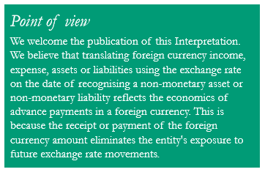

P&A Accounting Alerts are issued to keep our clients updated with the latest developments in financial reporting. These are not intended to be a substitute for professional advice. If you would like to unsubscribe, or add a colleague or a friend to our mailing list, please let us know by return e-mail. For inquiries and suggestions on how the Accounting Alert may be even more useful to you, e-mail Mabel.Comedia@ph.gt.com or Jerald.Sanchez@ph.gt.com or call 988-2288.

